 |   GATEWAY  PRIMARY SCHOOL  Lifelong love of learning | 

Headteacher: Kayleigh Anstee
Chair of Governors: Kevin Moyes

GOVERNOR
ANNUAL
COMMUNITY
REPORT

To: All members of the community
From: Governing Board
Date: 17 July 2023

Introduction
As part of our commitment to openness and transparency, we have prepared a 2023 report
about Governance at Gateway Primary School; we hope that you will find this summary both
informative and interesting as parents and members of the wider community.

School Improvement/Development
As you know, we were visited by an Ofsted inspection team earlier this year, and we are very proud to say Gateway School has now been graded 'Good' by Ofsted, with 'Outstanding Personal Development.' We are very excited about the continuing improvements we have planned for Gateway and the future of the school. We would like to say a huge thank you to the staff, parents/carers and the children for their support. The final report is attached here if you haven’t yet had a chance to read it.


We have continued to see the impact of all the hard work in creating such a positive reputation with the school community as a school which is truly inclusive, providing good quality education, great experiences for our pupils and excellent pastoral care and SEND provisions - as evidenced through continued increases to our pupil numbers which at present are 262, with 45 children due to start in EYFS in September 2023 – meaning that EYFS is full. This is amazing news for Gateway, and is the first time in a long time that EYFS has been full, so we are extremely pleased.

This year’s work has continued to strengthen our assessment process, moderation and provision of a rich and broad curriculum, as well as investments in staff CPD, strengthening school leadership, governors and staff vision of what good at Gateway looks like. The amazing progress in the school has been evidenced through Governor’s learning walks and other monitoring as well as external LA validation.

The behaviour of the pupils in the school has also been excellent with a clear pride and focus on their learning and pupils telling governors and Ofsted inspectors, how much they love their school and that there is not anything they would change. Attendance has continued to be strong this year sitting above the national average which makes a real difference to the progress our pupils make. Leaders and staff in school have worked incredibly hard to continue the school improvement journey and testament to this are the recent Phonics results which are in line with national results and the first time we have achieved at this level since before 2017. We are incredibly fortunate to have such a dedicated and professional team at our school.

It has also been positive to see so many school trips happen this year (and the clear enjoyment of the pupils in the photos) as well as visits to the RAF base and other school trips which all help to increase pupil independence and provide a rich learning experience. A big thank you to all volunteers who have helped with these trips.

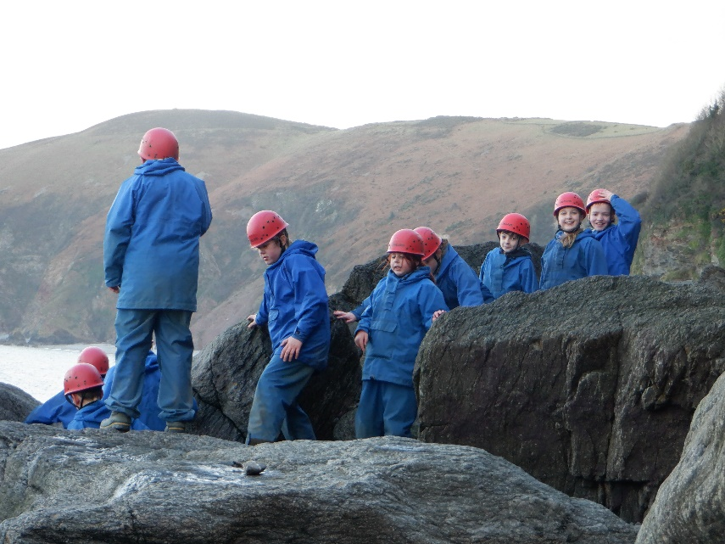

Governors

Governors at Gateway School provide strategic leadership and accountability. Amongst many other things, we hold the primary responsibility for the outcomes for the pupils and areas such as finance, where we work with Mrs Anstee to make the right decisions for the pupils. Each governor is a Governing Board member, which is established in law as a corporate body. We cannot act independently; decisions are the joint responsibility of the Governing Board, and it should be remembered that both Headteacher and one staff member are also governors. For details of your school governors, the work we do and all non-confidential governor documents, please visit the governor section of the school website.

The role of the Governing Board is a strategic one; its key functions are to:
- Ensure clarity of vision, ethos and strategic direction;
- Monitor and evaluate the progress the school is making towards the achievement of
its aims and objectives.
- Oversee the financial performance of the school and make sure its money is well spent
- Hold the Headteacher to account for the educational performance of the school and its pupils, and the effective and efficient performance management of staff.

This year the Governing Board has met 9 times and in addition to attending various events,
have undertaken 30 monitoring activities including in school visits to monitor areas such as
safeguarding, inclusion, staffing, health and safety and teaching and learning. In addition, the Governing Board had oversight of the monitoring reports from external visits (of which there were 30 this year), including the Local Authority School Improvement Team (including full school reviews and safeguarding audits). These monitoring visits enable insightful reports to be produced, thereby enabling the full Governing Board to hold the Headteacher and the leadership team to account for the achievement of our School Development Plan and pupil progress.

There are two key documents which help guide the governors in holding the school leadership
team to account for school improvement. These are the school Self-Evaluation Form (SEF),
which defines the current state of the school in terms of strengths and areas for improvement
according to the Ofsted headings; and the School Development Plan, which sets out the
actions to be taken to ensure that these areas for improvements are tackled. The Headteacher
prepares both documents, which are scrutinised, and agreed upon by the governors based on
their knowledge of the school and then used as the basis of which the leadership team can be
held to account. These are live documents and updated frequently as the school evolves, coming to the Full Governing Board each time for discussion and approval. Several techniques are deployed to ensure accountability, and these include challenging/holding the Headteachers and Leaders to account at governor meetings, conducting governor monitoring visits of the school when teachers and pupils can be questioned, and seeing children's work to gather evidence that objectives set out in the School Development Plan are being met.

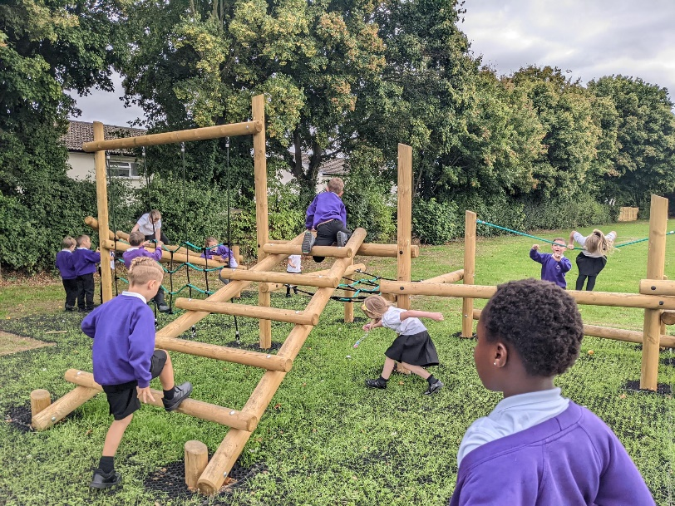

The areas that governors have been focusing on are varied and numerous, but our 2022-2023
School Development Plan targets (which governors have held the school leadership team to
account for) were:
- Improve the quality of leadership, management, and Governance.
- Further strengthen the quality of teaching, learning and assessment so that all groups of pupils make good or better progress
- Further develop identified areas of the whole school curriculum
In addition, governors had the following 2023-2024 objectives:
- Ensure Governance is impactful, robust, and sustainable.
- Ensure the Full Governing Board contributes towards rapid school improvement.
- Improve community engagement and ensure the community are aware of the work
of governors.
- Promote and grow the school.
- Promote Mental Health and Wellbeing for Pupils and Staff

These are essential, but the governors must also consider practical affairs that underpin the school's activities. This includes finance. We faced the year with a challenging financial position. However, with prudent management by the leadership team and Mrs Lock, our School Business Manager, and strong oversight by governors, we have been able to ensure money is spent on the areas needed to positively impact our pupils whilst at the same time balancing the budget over the agreed LA budget period. This achievement is a tribute to the efforts of the whole school community. However, the key to our future success in improving our budget will be to continue to increase pupil numbers. The leadership team and governors will make a concerted effort to publicise and promote our school, including the promotional video available on our website. We would also ask you to help with this
endeavour.

In our last meeting of the school year governors conducted a self-review of the effectiveness
of Governance at Gateway School. This review showed that we know our role as governors and we hold our leaders to account for the quality of education that our school provides and ensure that they manage resources wisely. We are prepared to intervene when leadership falls short and to celebrate when there is success.

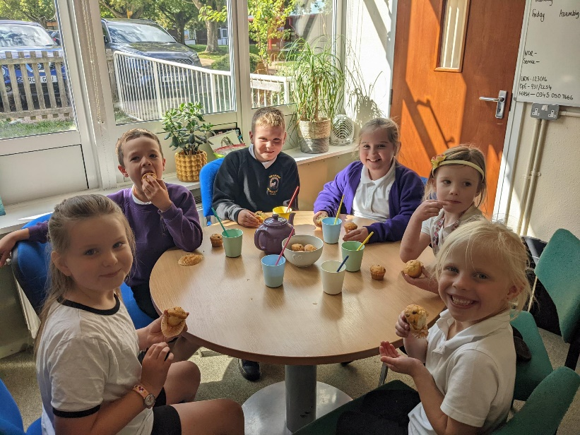

Looking to the future

The Governing Board and school leaders have a clear vision, strategy and high ambitions for
our school as well as a plan for big achievements in 2023-2024. Prior to the Good Ofsted rating the focus was more on understanding what good at Gateway looks like. Following the Good Ofsted report Governors will review how they monitor the school and hold them to account and align visits more closely with the School Development Plan. Our school improvement strategy takes a holistic approach recognising that it is a combination of quality of teaching, inspiring curriculum, accurate assessment of pupil progress, reflective learning by children, professional development of teaching staff, and effective leadership by the Headteacher and senior staff that will achieve our aspirations. In short, our vision is that we are to be a' learning school' where all members of our community seek opportunities to learn and improve, whatever our level of experience and expertise, to never rest on our laurels.



Next year, in addition to the School Development Objectives, statutory and best practice
governance areas, governors will be focused on the following areas: -

Filling our governor vacancies

Planning community engagement around our school vision, ethos, and values

Looking at the school’s long-term vision (5 years plus)

How governors can build stronger engagement with the broad range of community groups associated with the school.
- Improving phonics training and vocabulary linked to subjects

Conclusion

It has been a tremendous year for our school with our ‘Good’ Ofsted with ‘Outstanding’ for personal development our Ofsted report was a testament to the incredible dedication and hard work of all colleagues in school and the strong leadership from Mrs Anstee and her leadership team.

I would also like to take this opportunity to wish our year six pupils the best of luck in their new schools, and we hope they will keep in touch and let us know how they are getting on.

We do have 3 parent governor vacancies and 1 co-opted Governor vacancy on the Full Governing Board, and if you would like to learn more or apply for the parent position, then you can find out more here or email me: kmoyes@gateway.oxon.sch.uk Please also share the Co-Opted vacancy with your networks.

The Governing Board of Gateway Primary School has fulfilled all its statutory and best practice.
duties, despite the challenges. The Governing Board has made excellent progress in overseeing the school development plan's implementation and has vigorously held the school leadership team to account to achieve rapid improvement for the children we serve. Governance at the school continues to be robust and will continue to strengthen next year. As the Chair of Governors, it has been a real privilege to lead the work of Governors this year in a school that is a unique and special place; it is a joy to work with such an energetic set of teachers, parents, children, and a matter of great fulfilment.

I hope you all have a lovely summer, and we look forward to seeing you all in September.



