“Head teacher for a day”: Interview by Peacocks.
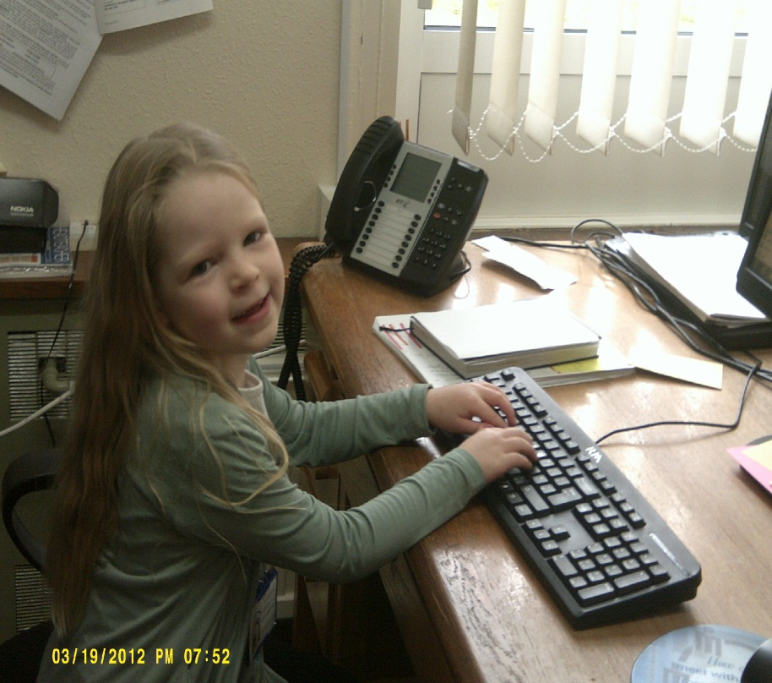 Busy at her desk.
Tom: What did you do today, was it fun?
Miss Lamberts: I picked who was going to go to the tea party, chose the donkey and answered the phone twice.
At the Coffee Morning
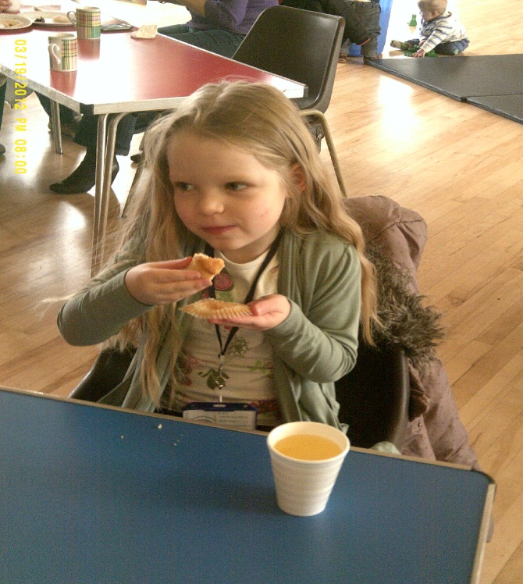
Chloe: What is the most amazing thing you did today?
Miss Lamberts: I chose the Head teacher’s tea party and the Donkey it was amazing.
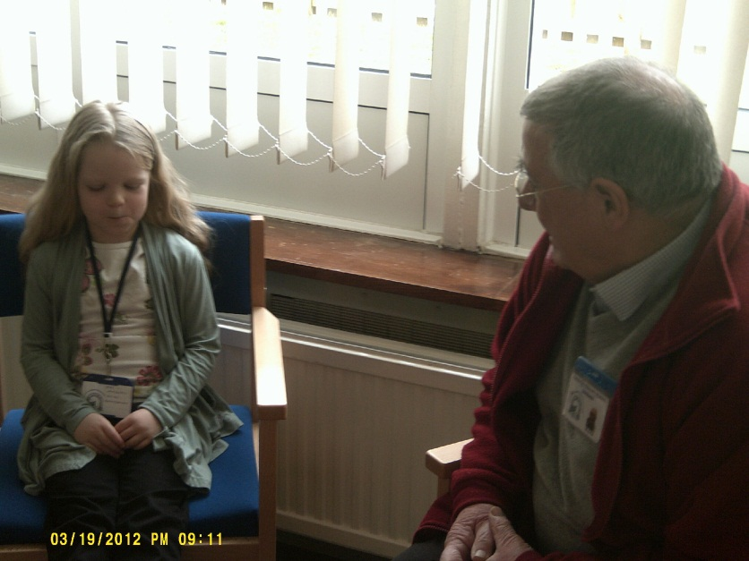 Meeting with Mr Fox
Caitlin: Do you know if you are going up to the front in assembly?
Miss Lamberts: Yes, I am.
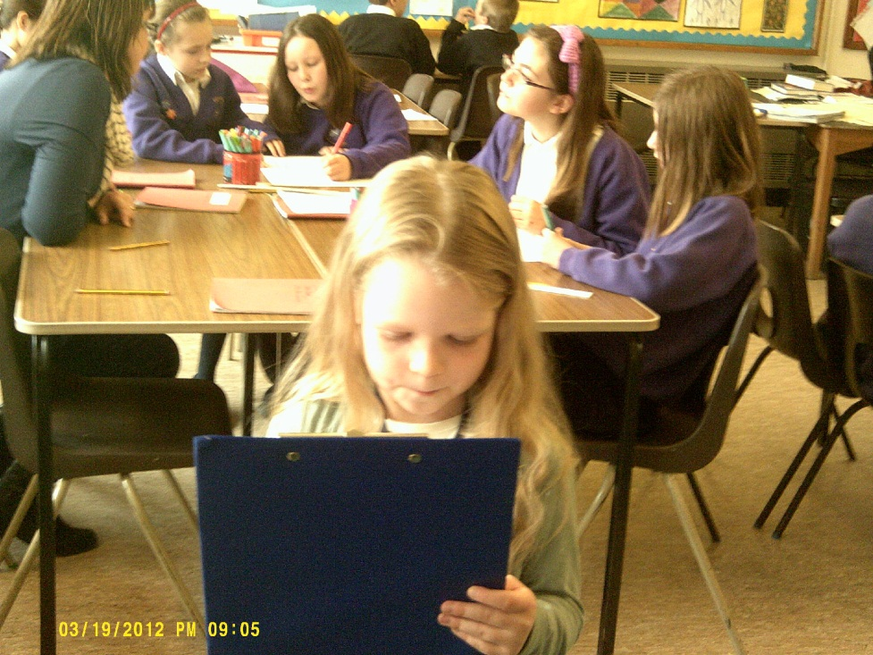
Carrying out a lesson Observation in Owls
Caitlin: How many raffle tickets did you get for the raffle?
Miss Lamberts: 1
Lauren: Did you think you would win?
Miss Lamberts: No, I didn’t.
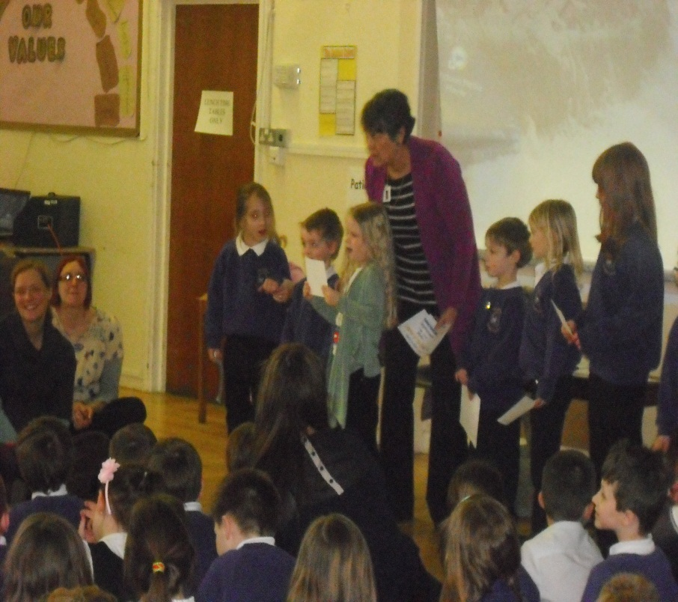
Handing out certificates in Celebration Assesmbly.

